**Guide to completing your Tenancy Data Sheet (TDS)**

Please take care to complete the TDS in full and correctly. Incomplete TDS’ may lead to multiple communications from the RTB.

To ensure the data provided in your completed TDS is secure, please save it with a password (Click on “Save As”, then “Tools”, then “General Options” and the “Password to Open” option) and send on the password in a separate email after returning the TDS.

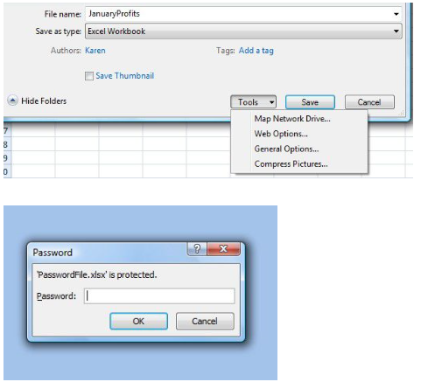

If you have an older version of excel the below screen shots should assist in password protecting your TDS.

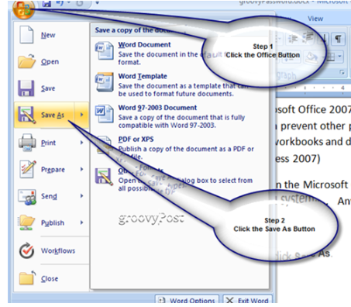

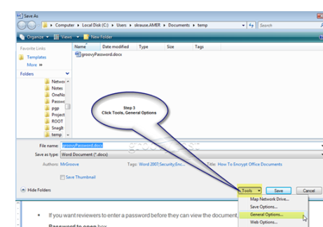

**Section 1:**

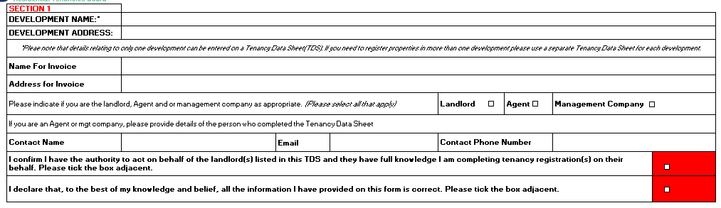

* Please provide the development name and address. Please note that details relating to only **one** development can be entered on a TDS. If you need to register properties in more than one development, please use a separate TDS for each development.
* Each TDS returned to the RTB will result in a single invoice only. Please complete a separate TDS for each invoice required. Please detail the name and correspondence address for the invoice.
* Please indicate who is completing the TDS i.e. Landlord, Agent and/or Management company (please select all that apply)
* If you are an Agent or management company, you must provide the following details of the person completing the Tenancy Data Sheet:
* Contact Name
* Email address
* Contact Phone no.
* If you are an Agent or management company, you must ensure to tick the declaration box stating *“I confirm I have the authority to act on behalf of the landlord(s) listed in this TDS and they have full knowledge I am completing tenancy registration(s) on their behalf”*
* Please tick the declaration* box to confirm that all information provided on the TDS is correct to the best of your knowledge

 *it is an offence to knowingly or recklessly furnish false or misleading information to the Residential Tenancies Board. If found guilty, a person shall be liable on summary conviction to a fine of up to €4,000 or a term of up to 6 months imprisonment or both

**Section 2- Landlord Details:**

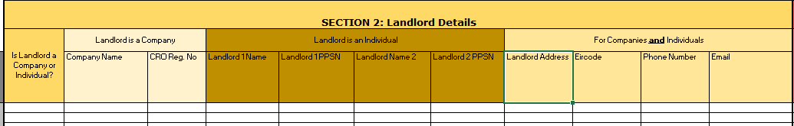

Please select whether the landlord is a company or individual and fill in the relating fields:

* Landlords Personal Public Service Number (PPSN) be provided where the landlord is an individual (There may be more than 1 landlord, therefore we have provided you with extra columns i.e. Landlord1/Landlord2 to allow for this).
* If the landlord is a company, then the registered number of that company (CRO) must be provided.

Please note the address of the landlord given on the TDS will be used by the RTB for corresponding with the landlord in relation to this tenancy.

**Section 3- Agent Details (if applicable):**

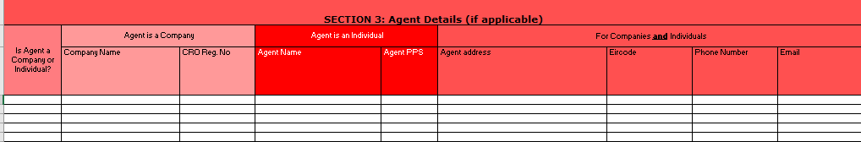

If applicable, the details of the person/company who is authorised to act on behalf of the landlord should be entered in this section.

Please select whether the agent is a company or individual and fill in the appropriate fields:

* Agent Personal Public Service Number (PPSN) is to be provided where the agent is an individual.
* If the Agent is a company, then the registered number of that company (CRO) must be provided.

**Section 4- Management Company Details (if applicable):**

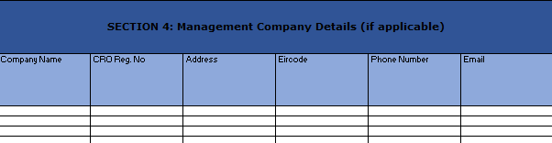

If applicable, the details of the management company should be provided in this section.

**Section 5- Address of Rented Dwelling:**

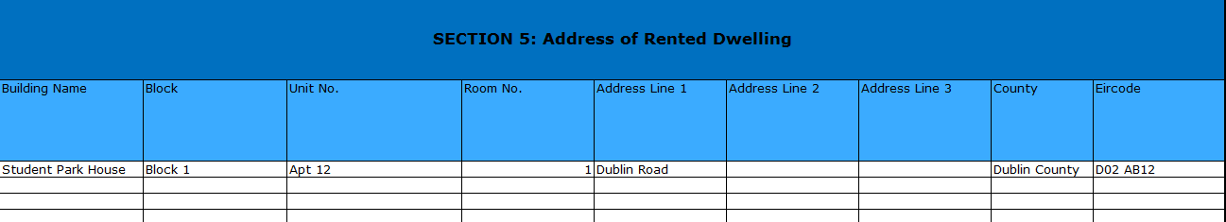

Example address St*udent Park House, Block 1, Apt 12, Room 1, Dublin Road, Co. Dublin, D02 AB12*

* **Building Name:** Please enter name of the building e.g. Student Park House
* **Block:** This could be a name or a number e.g. Student Hall or Block 1
* **Unit no:** This applies to units or apts that consist of 1 or more rooms e.g. Unit C or Apt 12
* **Room no:** Please assign each room a number or letter if they don’t already have one e.g. Room 1 or Room A

We are aware that all of these fields may not be applicable to your accommodation. Please insert N/A in the fields that are not applicable.

**Section 6- Tenancy Details:**

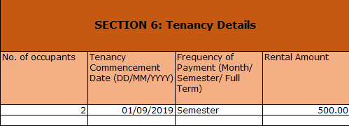

* **No. of occupants:**Please give the number of tenants in the room e.g. if it is a twin room there will more than likely be 2 tenants in the room
* **Tenancy Commencement Date:**This is the date the tenant(s) receives the key to their dwelling. This date should be entered in format of DD/MM/YYYY
* **Frequency of Payment:**This is how often the rent is paid to the landlord. Please choose between options of Month/Semester/Full Term. If you receive rent in instalments, we would suggest you choose the option of “full term” and give the rent amount for the full academic year.
* **Rental Amount:**This is the rent amount paid each Month/Semester/Full Term for the room (not tenant). This should be entered in the format 1234 or 1234.56 as appropriate. The cell will display the euro amount to two decimal places by default.

**Section 7- Composite**

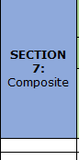

This section is used to identify composites. If the dwelling is part of a composite please select “Yes” from the drop down list. We’d recommend you list your tenancies by groups of composites. We have attached a separate Composite guide to assist you in identifying them.

**Section 8- Tenant Details:**

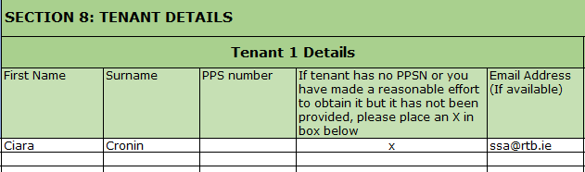

Please provide the details of the tenant(s) residing in each room. There may be more than 1 tenant in each room, therefore we have provided you with extra columns to allow for this.

Please be aware that *First Name* and *Surname* are the only mandatory fields within the green columns. However, if the tenant does not have a PPSN or you are unable to provide tenant PPS number, you must ensure to place X in the column confirming that you made a reasonable effort to obtain same.

**Fee Structure**

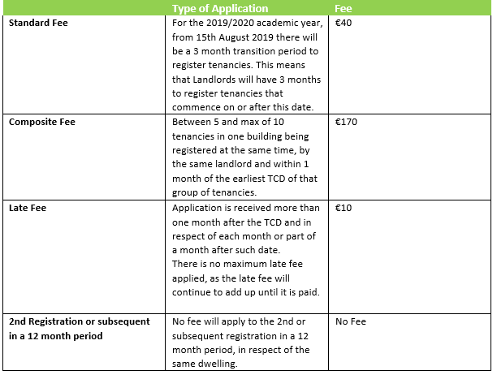

*TCD= Tenancy Commencement Date

**Copying and Pasting into Tenancy Data Sheet:**

Please note that certain fields have been locked to preserve the formatting of the TDS so you will not be able to delete rows or columns, but you will of course still be able to delete any data you enter by selecting the relevant cell(s) and pressing the Delete key.

There is an issue with Excel around the copy and paste function in a locked workbook. The issue relates to formatting.

When a user copies from another source and pastes into their Tenancy Data Sheet (TDS) they are changing the status of the cell from “Unlocked” to “Locked”.  **When the user goes to edit or delete the cell, an error message appears.**

Unfortunately, Excel does not currently provide any inbuilt way of countering this.

To help you complete your TDS, please find below instructions on how to avoid any error messages.

Unfortunately, we can’t cover every scenario but hopefully this will assist.

* When copying info within your TDS or from other excel docs, the following Paste options will appear, choose the “Values” option as circled in red in the pic below.

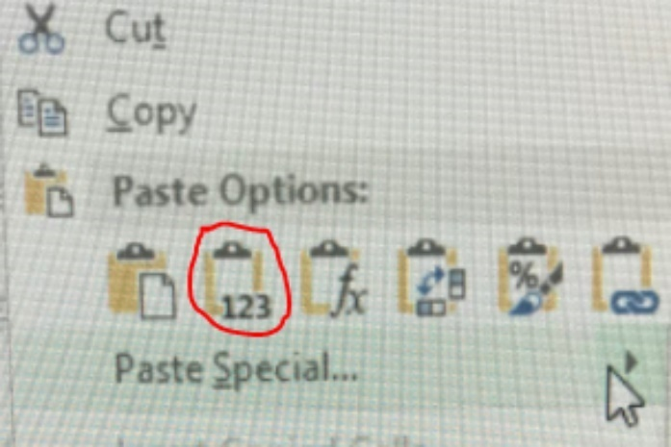

* When copying info from another source into your TDS you can use the “match destination formatting” paste option. See screen shot below:

